|  |  |
| --- | --- |
|  | **03/05/2020** |
|  | Weather Station Addendum This project is complete and Deployed in my yard  However  Due to the power consumption issues and size of batterry pack there are many improvements to be made  Thus  Revision 1.x versions will no longer be updated in favour of a rev 2.x (time permitting) |

|  |
| --- |
| Weather Station |
|  |

Weather Station

# Introduction

A Weather station is a device that collects data related to the weather and environment using many different sensors. We can measure many things like:

* Temperature
* Humidity
* Wind
* Barometric Pressure
* UV index
* Rain

My inspiration to create this weather station came from this source along with the code which was modified to my purpose using Arduino Nano as main board and thing speak to send data to.

<https://www.instructables.com/id/Arduino-Uno-Wireless-Weather-Station-Wundergroundc/>

ESP8266 WiFi module will send data to www.thingspeak.com

Thingspeak is a clous data collection service.

The following sensors were used:

Humidity, Pressure - BME280

UV, Solar - ML8511

Anenometer, wind directionand rain guage (3D printed)

## Power Supply

6x18650 cells will be used to power the project 3s2p and will be chard by solar during daytime hours. They fit inside the central control box with the PCB (see 3d Prints)

The original intent was to use 3x18650 in series to provide 12V but there are issues with power consumption and the battery life overnight.

Battery management is by ab 18650 BMS balance protection/charging board such as this

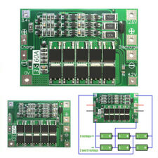

## Sensors

|  |  |
| --- | --- |
| Temperature,Humidity and Barometric Pressure | Sparkfun BME280 |
| UV index | ML8511 |
| Wind Speed | Hall effect sensor and Magnet |
| Rain | Hall effect sensor and Magnet |
| Wind Direction | CJMCU-103 Angle Sensor |

# 3D Printed Parts

STL files included for 3d printing.

Created by SeanTheITGuy on thingiverse

<https://www.thingiverse.com/SeanTheITGuy/collections/arduino-weather-station>

The Anemometer and Rain bucket use Hall effect sensors and magnets

The Wind vane uses CJMCU-103 Angle Sensor

Printer settings as follows:-

Material: PLA

Nozzle Dia: 0.4

Layer height: 0.2

Support: Use tree support where possible

Skirt: Yes

Infill: 33% or higher

# Schematic

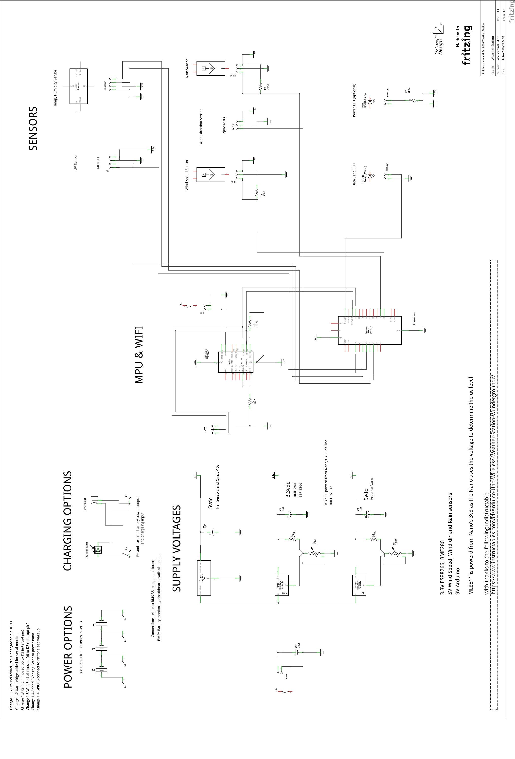

# PCB

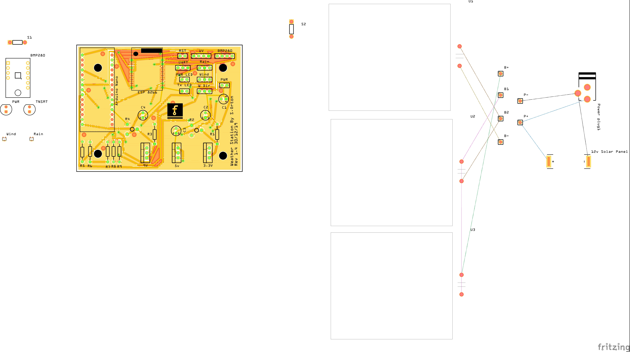

# BOM—Bill of Materials

## Assembly List

|  |  |  |
| --- | --- | --- |
| Label | Part Type | Properties |
| 12v Solar Panel | SOLAR-IXYS | package solarbit-12x1; variant - |
| 3.3V | Voltage Regulator - Variable | voltage Variable V; package TO220 [THT] |
| 5v | Voltage Regulator - 5V | voltage 5V; package TO220 [THT] |
| 9V | Voltage Regulator - Variable | voltage Variable V; package TO220 [THT] |
| Arduino Nano | Arduino Nano (Rev3.0) | type Arduino Nano (3.0) |
| B+ | Generic female header - 1 pins | pins 1; row single; form ♀ (female); package THT; hole size 1.0mm,0.508mm; pin spacing 0.1in (2.54mm) |
| B- | Generic female header - 1 pins | pins 1; row single; form ♀ (female); package THT; hole size 1.0mm,0.508mm; pin spacing 0.1in (2.54mm) |
| B1 | Generic female header - 1 pins | pins 1; row single; form ♀ (female); package THT; hole size 1.0mm,0.508mm; pin spacing 0.1in (2.54mm) |
| B2 | Generic female header - 1 pins | pins 1; row single; form ♀ (female); package THT; hole size 1.0mm,0.508mm; pin spacing 0.1in (2.54mm) |
| BMP280 | BME280 Breakout | power 3.3V; variant BME280 |
| BMP280 | Generic female header - 4 pins | pins 4; row single; form ♀ (female); package THT; hole size 1.0mm,0.508mm; pin spacing 0.1in (2.54mm) |
| C1 | Electrolytic Capacitor | voltage 6.3V; package 100 mil [THT, electrolytic]; capacitance 10µF |
| C2 | Electrolytic Capacitor | voltage 6.3V; package 100 mil [THT, electrolytic]; capacitance 1µF |
| C3 | Electrolytic Capacitor | voltage 6.3V; package 100 mil [THT, electrolytic]; capacitance 1µF |
| C4 | Electrolytic Capacitor | voltage 6.3V; package 100 mil [THT, electrolytic]; capacitance 1µF |
| ESP 8266 | ESP8266 WiFi Module | variant variant 7; part # ESP8266 |
| P+ | Generic female header - 1 pins | pins 1; row single; form ♀ (female); package THT; hole size 1.0mm,0.508mm; pin spacing 0.1in (2.54mm) |
| P- | Generic female header - 1 pins | pins 1; row single; form ♀ (female); package THT; hole size 1.0mm,0.508mm; pin spacing 0.1in (2.54mm) |
| Part2 | Schematic Frame | rev 1.4; descr Arduino Nano and Esp 8266 Weather Station; date 1576360492; project Weather Station; sheet 1/1; filename Weather Stn R 1.4.fzz |
| Power plug1 | Power plug |  |
| PWR | Red (633nm) LED | package 5 mm [THT]; color Red (633nm); leg yes |
| PWR | Generic female header - 2 pins | pins 2; row single; form ♀ (female); package THT; hole size 1.0mm,0.508mm; pin spacing 0.1in (2.54mm) |
| PWR LED | Generic female header - 2 pins | pins 2; row single; form ♀ (female); package THT; hole size 1.0mm,0.508mm; pin spacing 0.1in (2.54mm) |
| R1 | 270Ω Resistor | tolerance ±5%; resistance 270Ω; package THT; bands 4; pin spacing 400 mil |
| R2 | Trimmer Potentiometer | maximum resistance 10kΩ; package THT; type Trimmer Potentiometer; size Trimmer - 6mm; track Linear |
| R3 | 270Ω Resistor | tolerance ±5%; resistance 270Ω; package THT; bands 4; pin spacing 400 mil |
| R4 | Trimmer Potentiometer | maximum resistance 10kΩ; package THT; type Trimmer Potentiometer; size Trimmer - 6mm; track Linear |
| R5 | 10kΩ Resistor | tolerance ±5%; resistance 10kΩ; package THT; bands 4; pin spacing 400 mil |
| R6 | 150Ω Resistor | tolerance ±5%; resistance 150Ω; package THT; bands 4; pin spacing 400 mil |
| R7 | 150Ω Resistor | tolerance ±5%; resistance 150Ω; package THT; bands 4; pin spacing 400 mil |
| R8 | 10kΩ Resistor | tolerance ±5%; resistance 10kΩ; package THT; bands 4; pin spacing 400 mil |
| R9 | 10kΩ Resistor | tolerance ±5%; resistance 10kΩ; package THT; bands 4; pin spacing 400 mil |
| Rain | HALL-EFFECT | package sc70; variant smd |
| Rain | Generic female header - 3 pins | pins 3; row single; form ♀ (female); package THT; hole size 1.0mm,0.508mm; pin spacing 0.1in (2.54mm) |
| RST | Generic female header - 2 pins | pins 2; row single; form ♀ (female); package THT; hole size 1.0mm,0.508mm; pin spacing 0.1in (2.54mm) |
| S1 | Pushbutton | package THT; switching circuit SPST; default state Normally Open |
| S2 | Pushbutton | package THT; switching circuit SPST; default state Normally Open |
| TNSMT | Green (560nm) LED | package 5 mm [THT]; color Green (560nm); leg yes |
| Tx LED | Generic female header - 2 pins | pins 2; row single; form ♀ (female); package THT; hole size 1.0mm,0.508mm; pin spacing 0.1in (2.54mm) |
| U1 | LIPO-2000mAh | package lipo-2000; variant 2000mAh |
| U2 | LIPO-2000mAh | package lipo-2000; variant 2000mAh |
| U3 | LIPO-2000mAh | package lipo-2000; variant 2000mAh |
| UART | Generic male header - 3 pins | pins 3; row single; form ♂ (male); package THT; hole size 1.0mm,0.508mm; pin spacing 0.1in (2.54mm) |
| UV | Generic female header - 4 pins | pins 4; row single; form ♀ (female); package THT; hole size 1.0mm,0.508mm; pin spacing 0.1in (2.54mm) |
| W Dir | Generic female header - 3 pins | pins 3; row single; form ♀ (female); package THT; hole size 1.0mm,0.508mm; pin spacing 0.1in (2.54mm) |
| Wind | HALL-EFFECT | package sc70; variant smd |
| Wind | Generic female header - 3 pins | pins 3; row single; form ♀ (female); package THT; hole size 1.0mm,0.508mm; pin spacing 0.1in (2.54mm) |

## Change Log

|  |  |  |  |
| --- | --- | --- | --- |
| Date | Doc Rev. | Board Rev. | Change |
| 03/05/2020 | 1.4.0 | 1.4 | First Document Issue |